**ASSIGNMENT 2.1**

1) Write a java code with the class named ‘acad’ and a method ‘main’. Hard Code the program with two integers and print the sum of those two.

**Java Code:**

Hard coded the two variables and displays sum.

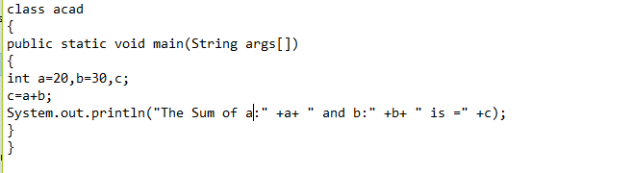

**Output:**

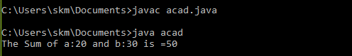

2) Rewrite the above code, where, inputs are provided by the user at runtime and the output is printed.

**Java code:**

Gets the input from user at runtime using Scanner(System.in) and displays sum.

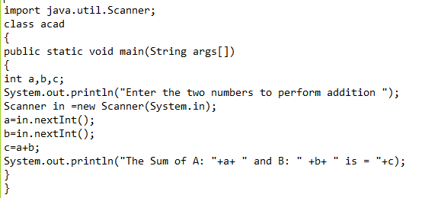

**Output:**

Prompted for two values and then program displayed the sum.

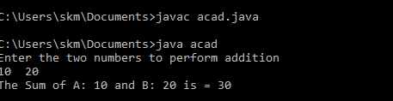

3) Write a program with method name sum() that accepts two parameters from user and print the sum of two numbers.

Output format should be as:

First number is:

Second number is:

Sum is:

**Java code:**

Gets the input from user at runtime using Scanner(System.in) and calls the sum() function with two parameters. Sum() – performs sum of two inputs

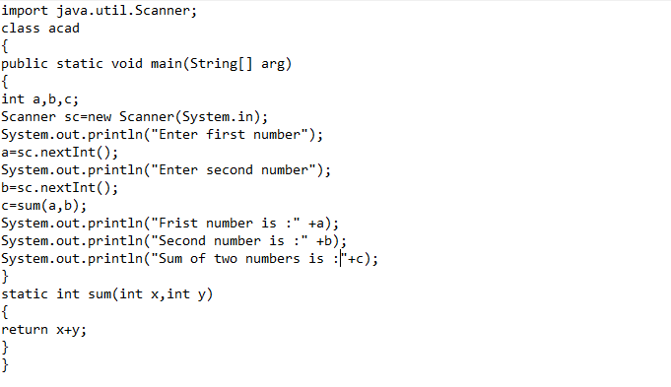

**Output:**

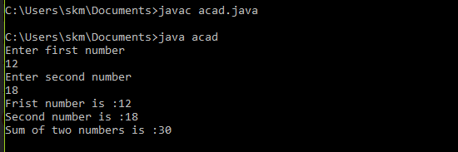

4) Write a program to accepts two numbers from stdin and find all the odd as well as even numbers present in between them.

**Java code:**

Get the two numbers at runtime using Scanner(System.in) and prints the odd and even no list between the range.

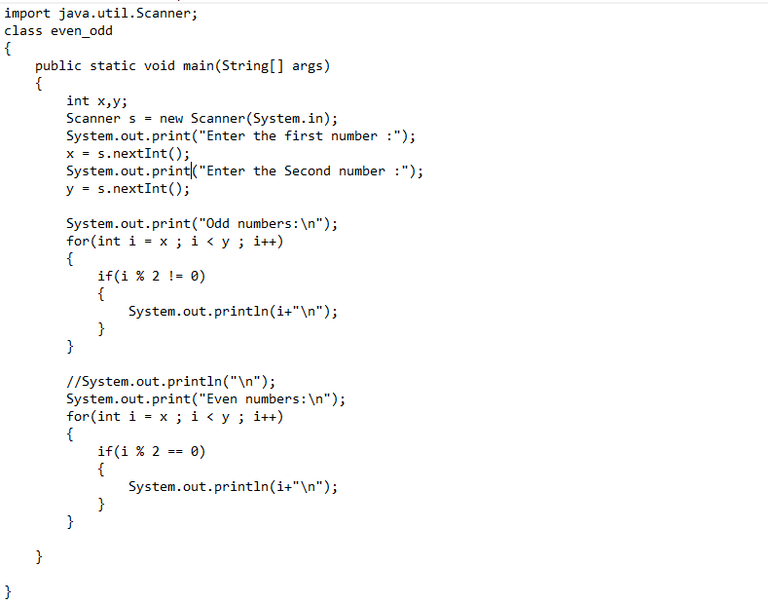

**Output:**

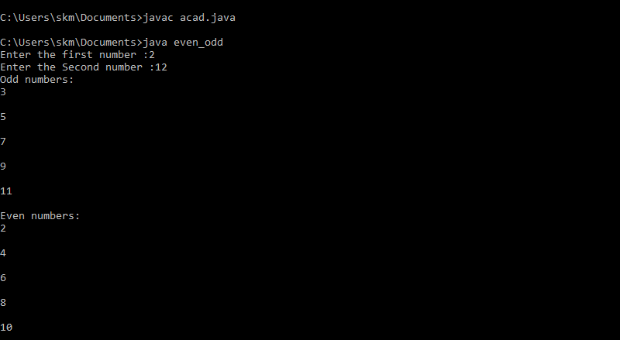

5) Joe is scared to go to school. When her dad asked the reason, joe said she is unable to complete the task given by her teacher. The task was to find

the “first 10 multiples” of the number entered from stdin.

Eg:

Input: 3

O/p:

3 x 1 = 3

3 x 2 = 6

………

3 x 10 = 30 Help Joe in completing the task!

**Java code:**

Get the number for which 10 multiples needs to be displayed using Scanner and displays 10 multiples.

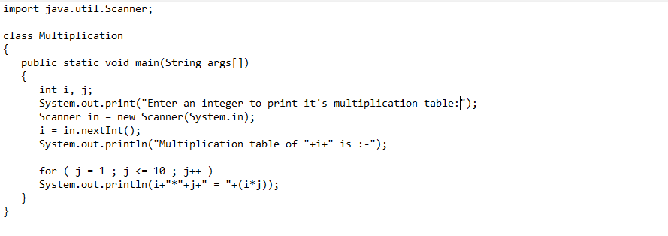

**Output:**

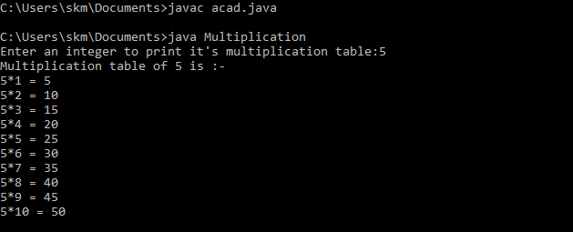

6) Write a program consisting method sum() and demonstrate the concept of method overloading using this method.

**Java code:**

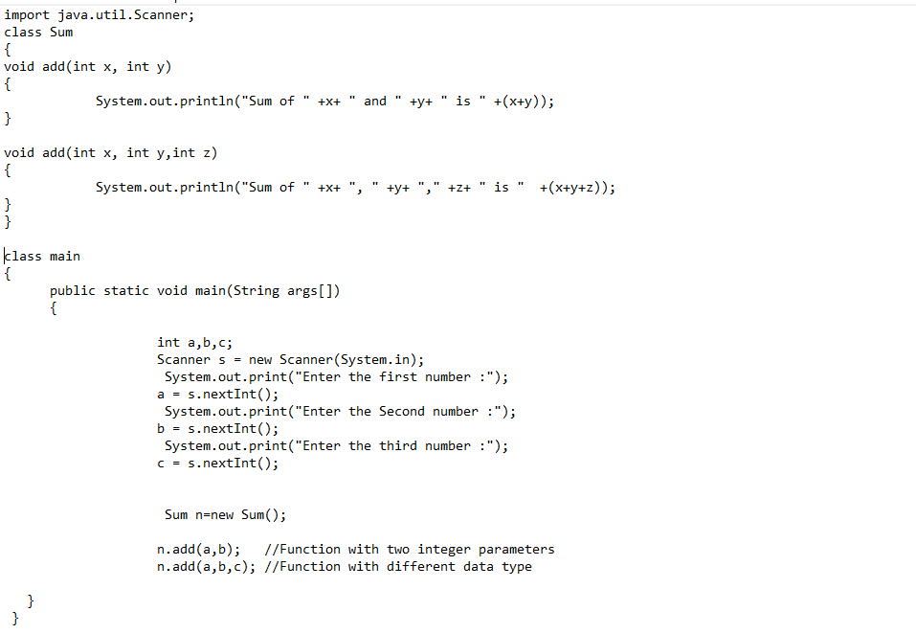

**Output:**

Calls specific funtions according to the overloaded type. 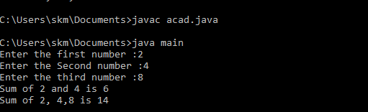

7) Can you overload a method with same return type.? Explain your answer with proper logic.

No, we can’t overload a method with same return type.

Overloading means having two or more methods in a class with the exact same name but different parameter types or different number of parameters or both.

Return type of the method is not included in the method signature of java.

**Example:**

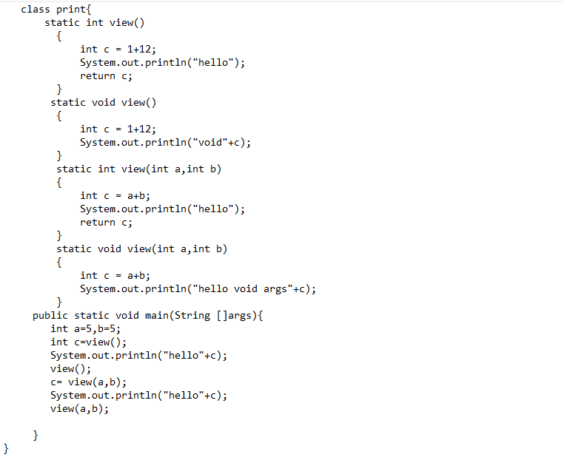

**Output**

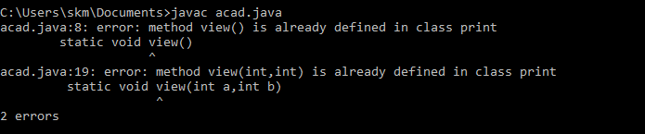

8) Write a program in java using Arrays, that sorts the element in descending order.

**Java code:**

Gets the number of elements to be added to the array at run time and creates array dynamically. Prints the array in descending order.

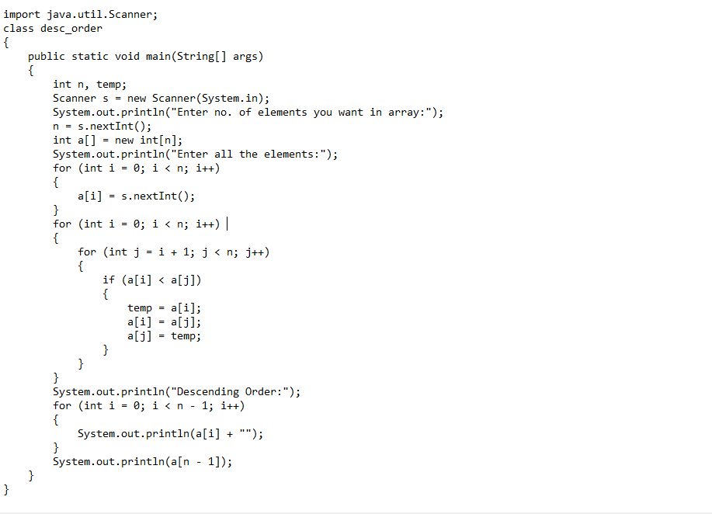

**Output:**

